**Recommendation system**

There are three approaches that we can do Recommendation system

**1)Collaborative filtering**

Collaborative filtering uses algorithms to filter data from user reviews to make personalized recommendations for users with similar preferences.

Collaborative means collaboration multiple people come together so the there will be costumers whose rating will be same like people who love comedy movies or similar behavior between rating among the movies it works on or

The feedback about movies falls into one of two categories:

**Explicit**— users specify how much they liked a particular movie by providing a numerical rating.

**Implicit**— if a user watches a movie, the system infers that the user is interested.

collaborative filtering uses similarities between users and items simultaneously to provide recommendations

1**.Calculate similarity among the items:**

Cosine-Based Similarity

Correlation-Based Similarity

Adjusted Cosine Similarity

1-Jaccard distance

For more info. And Reference :- [Collaborative Filtering](https://developers.google.com/machine-learning/recommendation/collaborative/basics)

**1)User item interaction matric (Implicit rating)**

Suppose if there is no rating on item how we will find the similarity between user so what we will do we will replace the rating system to some another measure is user behavior like screen time ,click rate etc we will create user item interaction matrix and we will find the similar behaviors between them

*scenarios

What if we Suppose have 1 million users how we will find similar users so we will use Euclidian distance

What if user don’t rate the movie at all so we will normalize the value before computing distance

**User-based collaborative Filtering**

User-Based Collaborative Filtering is a technique used to predict the items that a user might like on the basis of ratings given to that item by the other users who have similar taste with that of the target user.

Build a matrix of things each user bought/viewed/rated

Compute similarity scores between users

Find users similar to you

Recommend stuff they bought/viewed/rated that you haven't yet.

**Problems with User-Based CF**

People are fickle; tastes change

There are usually many more people than things

People do bad things

**Item base collaborative filtering**

Item based collaborative filtering was introduced 1998 by Amazon. Unlike user based

collaborative filtering, item based filtering looks at the similarity between different items, and

does this by taking note of how many users that bought item X also bought item Y

1)find similar items rated by user

2)based the historical rating it will recommend me next item

Item-item collaborative filtering is a type of recommendation system that is based on the

similarity between items calculated using the rating users have given to items

**1.Calculate similarity among the items:**

Cosine-Based Similarity

Correlation-Based Similarity

Adjusted Cosine Similarity

1-Jaccard distance

**2.Calculation of Prediction:**

Weighted Sum

Regression

**So what is the difference between user and item based collaborative filtering**

Item based collaborative filtering finds similarity patterns between items and recommends them to users based on the computed information, whilst user based finds similar users and gives them recommendations based on what other people with similar consumption patterns appreciated

For more info. And Reference:- [link](http://www.diva-portal.org/smash/get/diva2:1111865/FULLTEXT01.pdf)

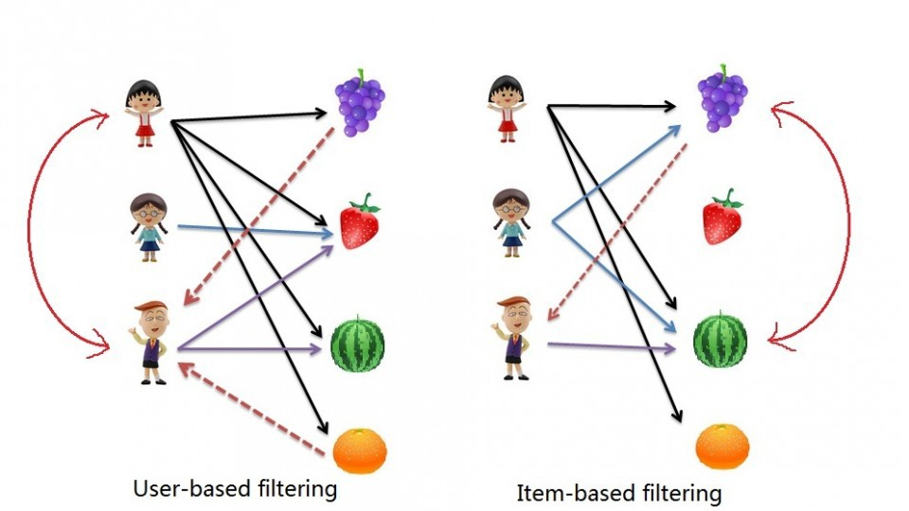

**So collaborative filtering has two variants**

**1)model based collaborative filtering**

Try to predict next best item user (maybe new item) we try top fit model

**2)memory based collaborative filtering**

We take historical data We just focus memory of user and who similar to it we will recommend

**Drawbacks of collaborative filtering**

1)consumes lots of memory and computation power

2)only famous item recommend

3)new items not recommended at all

**2)Content Based**

Content-based filtering uses item features to recommend other items similar to what the user likes, based on their previous actions or explicit feedback.

It will take item attributes in consideration for example if you watch the horror movie then all the horror movie start suggesting to you

The main difference between collaborative and content based recommend system is collaborative filtering does not take item or user attributes in consideration just work on user item interaction matrix but in content based it will take item or user attributes for example what is age gender demographics ,personal taste ,behavior etc what are the item attribute like is my product grocery or electronic or is my movie is comedy, horror, action, adventure etc

**Advantage** of content based collaborative filtering is

1)it take less computation and memory power

2)does not suffer the new product recommendation because it take the consideration of user-item attributes

3)the model doesn't need any data about other users, since the recommendations are specific to this user. This makes it easier to scale to a large number of users.

4)The model can capture the specific interests of a user, and can recommend niche items that very few other users are interested in.

**Disadvantages**

Since the feature representation of the items are hand-engineered to some extent, this technique requires a lot of domain knowledge. Therefore, the model can only be as good as the hand-engineered features.

The model can only make recommendations based on existing interests of the user. In other words, the model has limited ability to expand on the users' existing interests.

**3)content based + collaborative filtering(hybrid)**

**Recommender system**

Hybrid

Content base filtering

Collaborative filtering

Memory based

Content base filtering

User based

Item based